1. **Develop a simple JSP application to display values obtained from the use of intrinsic object of various types.**

**Code:**

**Filename:new.jsp**

<%@page contentType="text/html" pageEncoding="UTF-8"%>

<!DOCTYPE html>

<html>

<head>

<meta http-equiv="Content-Type" content="text/html; charset=UTF-8">

<title>JSP Page</title>

</head>

<body>

**<h1>Use of Intrinsic Object in JSP</h1>**

**<h2>Request Objects</h2>**

**Query String <%=request.getQueryString()%><br>**

**Context Path <%=request.getContextPath()%><br>**

**Remote Host <%=request.getRemoteHost()%><br>**

**<h2>Response Object</h2>**

**Character Encoding Type <%=response.getCharacterEncoding()%><br>**

**Content Type <%=response.getContentType()%><br>**

**Local <%=response.getLocale()%><br>**

**<h2>Session Object</h2>**

**Session ID <%=session.getId()%><br>**

**Creation Time <%=new java.util.Date(session.getCreationTime())%><br>**

</body>

</html>

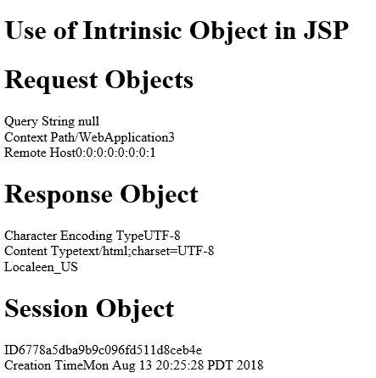

4B: **Develop a simple JSP application to pass values from one page to another page with validations.**

**Code:**

**Index.html**

Top of Form

Bottom of Form

Top of Form

Top of Form

<html>

<head>

<title>TODO supply a title</title>

<meta charset="UTF-8">

<meta name="viewport" content="width=device-width, initial-scale=1.0">

</head>

<body>

**<form action="Validate.jsp">**

**Enter Your Name<input type="text" name="name"><br>**

**Enter your Age<input type="text" name="age"><br>**

**Select Hobbies**

**<input type="checkbox" name="hob" value="Singing">Singing<br>**

**<input type="checkbox" name="hob" value="Reading">Reading<br>**

**Select Gender**

**<input type="radio" name="gender" value="male">Male<br>**

**<input type="radio" name="gender" value="female">Female<br>**

**<input type="hidden" name="error" value=""><br>**

**<input type="submit" value="REGISTER"><br>**

**</form>**

</body>

</html>

**Validate.jsp**

<%@page contentType="text/html" pageEncoding="UTF-8"%>

<!DOCTYPE html>

<html>

<head>

<meta http-equiv="Content-Type" content="text/html; charset=UTF-8">

<title>JSP Page</title>

</head>

<body>

**<h1>Validation Page</h1>**

**<jsp:useBean id="obj" scope="request" class="pack.CheckerBean">**

**<jsp:setProperty name="obj" property="*"/>**

**</jsp:useBean>**

**<% if(obj.validate())**

**{**

**%>**

**<jsp:forward page="successful.jsp"/>**

**<%}**

**else{**

**%>**

**<jsp:include page="index.html"></jsp:include>**

**<%}%>**

**<%=obj.getError()%>**

</body>

</html>

**CheckerBean.java**

package newpackage;

public class CheckerBean {

**private String name,age,hob,gender,error;**

public CheckerBean()

{

error=""

}

public String getName() { return name ;}

public void setName(String name) { this.name = name; }

public String getAge() { return age; }

public void setAge(String age) { this.age = age; }

public String getHob() {return hob; }

public void setHob(String hob) {this.hob = hob; }

public String getGender() { return gender; }

public void setGender(String gender) {this.gender = gender;}

public String getError() { return error; }

public void setError(String error) { this.error = error; }

**public boolean validate(){**

**boolean res=true;**

**if(name.trim().equals("")){**

**error+= "<br>Enter First Name";res=false;**

**}**

**if(age.length()>2){**

**error+= "<br>Age Invalid";res=false;**

**}**

**return res;**

**}**  }

**Successful.jsp**

<%@page contentType="text/html" pageEncoding="UTF-8"%>

<!DOCTYPE html>

<html>

<head>

<meta http-equiv="Content-Type" content="text/html; charset=UTF-8">

<title>JSP Page</title>

</head>

<body>

<h1>success!</h1>

</body>

</html>

**Output**

